Project Development Phase Delivery of Sprint 4 - Deployment

|  |  |
| --- | --- |
| **DATE** | 17 November 2022 |
| **TEAM ID** | PNT2022TMID10872 |
| **PROJECT NAME** | Inventory Management System for Retailers |

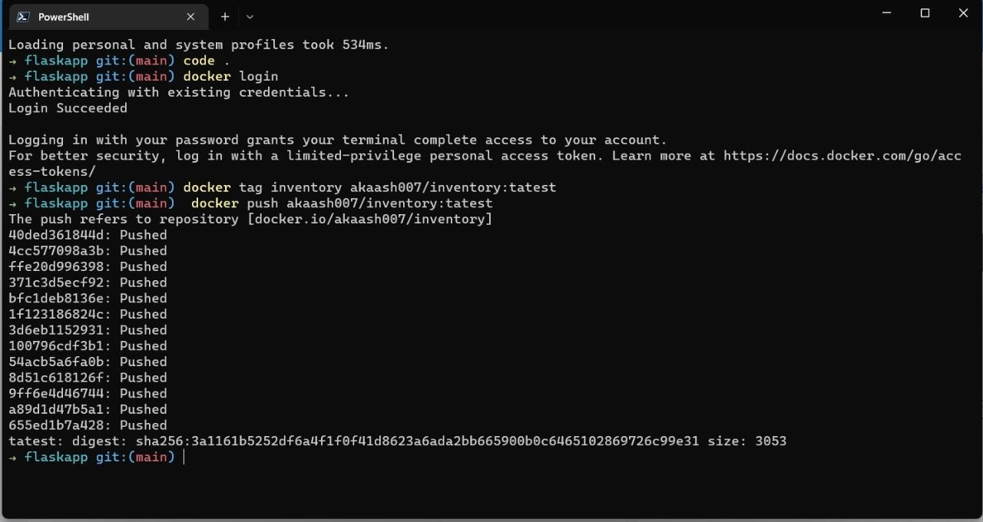Push Image to Dockerhub:

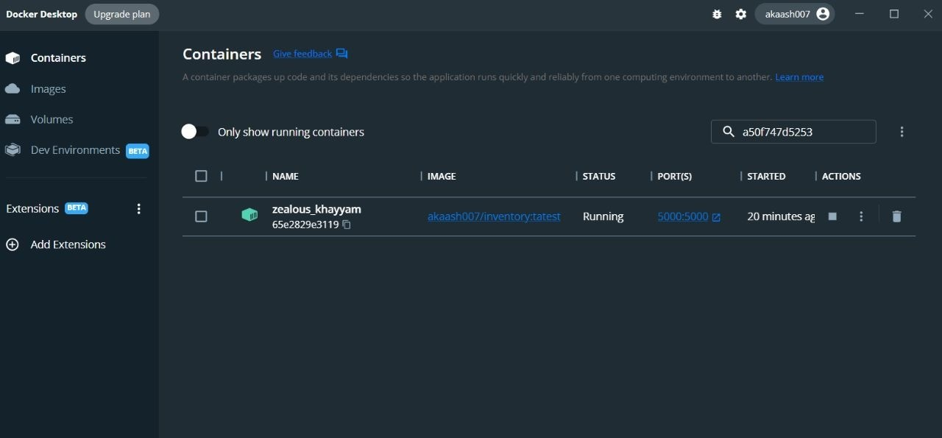Running the Docker Image in a Container:

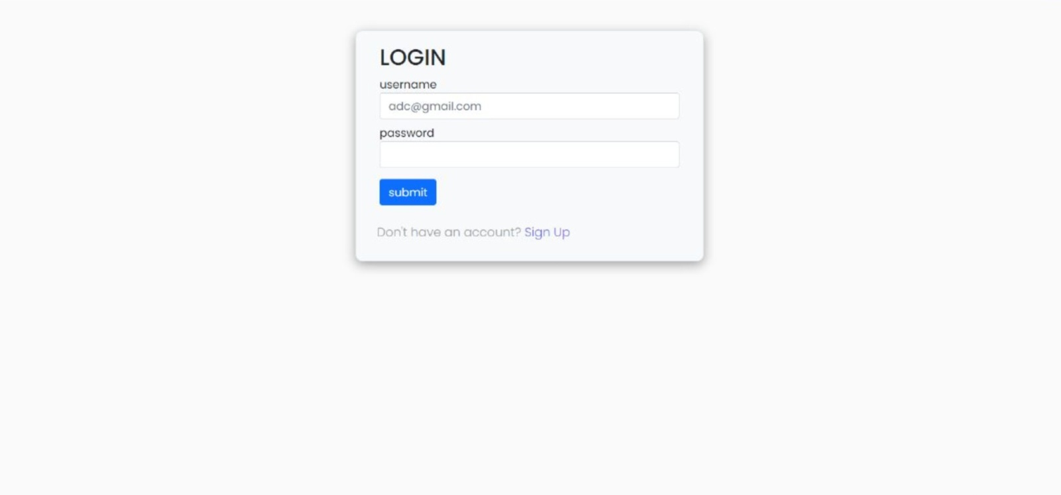Deployed App:

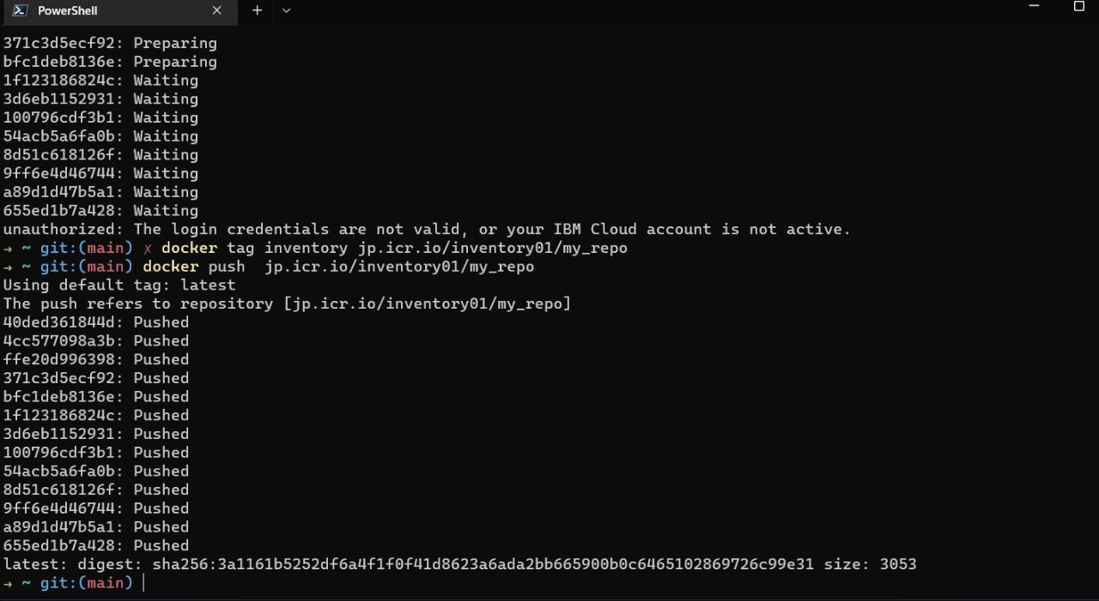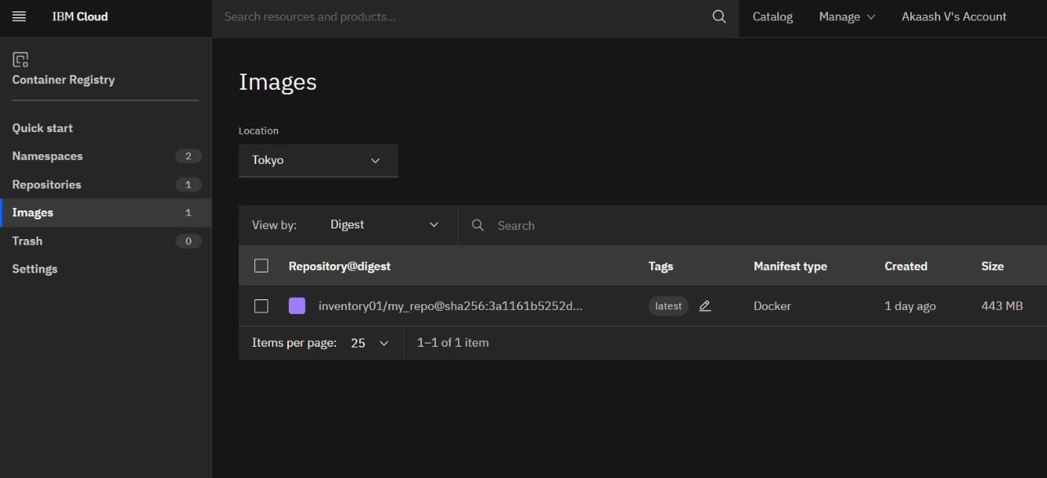Uploaded the image on the IBM container registry